01-March-2018

- Include menu bar at the bottom. Just like shown below. Change names to Explore, Messages, Notifications, My profile. Schedule is not required for right now.

- Community- There should be a Explore sub menu item on User profile screen.
Vasant & Dhaiyur Comment: What is the use of community functionality and how it should work as per you want, we didn't know about the community functionality work flow in PoGo Ride.
Community is nothing but a list of groups. For RideWhiz, if someone wants to search for new groups to join, they will use the Explore screen as mentioned below to send request to join one or more groups.

- Explore screen should list all the groups available with a join link to the right hand side as shown below.
Vasant & Dhaiyur Comment: Where we can see the “Explore screen” on PoGo Ride? And how it will work?
Explore menu is under Me submenu on the bottom menu bar.
- Invite users to a group. Implement all the options below.
Invite by email,
Invite by text message,
Use a different app
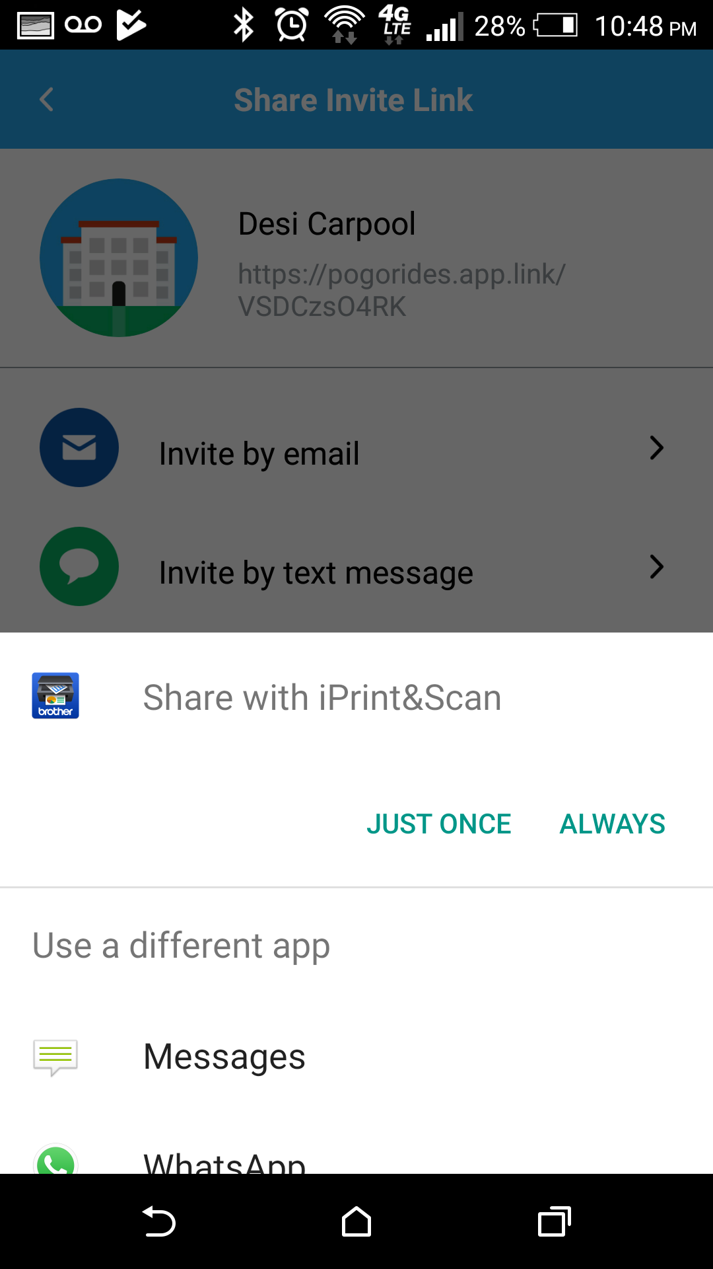
Vasant & Dhaiyur Comment: From where app user can invite user to group in RideWhiz app?

After creating a new group in RideWhiz, create a share link just under the group name. Clicking on the Share link should bring up the Invite screen with various options as shown below. Try creating a new group in Pogo Rides. You will see the option to invite users at the end of it.

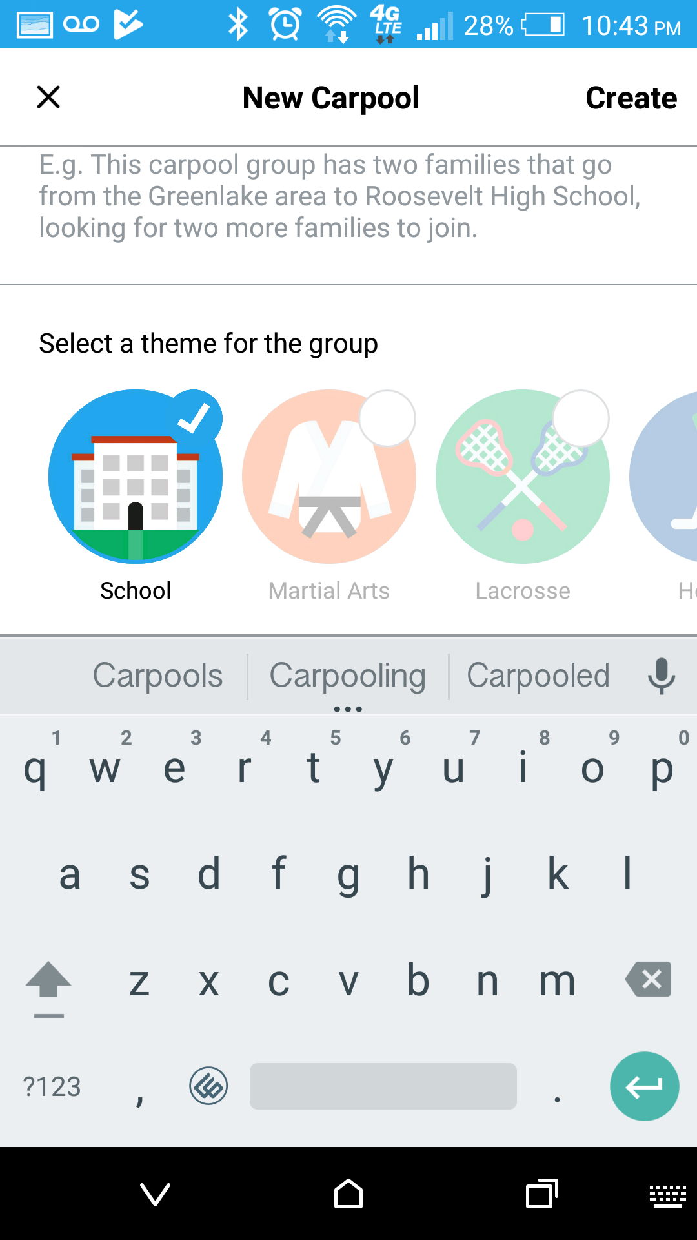
- Create a new group screen as shown below. Let users choose a name for the group, enter description and also select a theme.
Vasant & Dhaiyur Comment: Please provide the per-defined list of theme. Also group name will be unique in app?
Yes, group name will be uniquely identified. Themes are school, soccer, tennis, lacrosse, baseball, basketball, music, etc. We will provide you with the icons for the themes.

Invite people to a group. Implement as shown below.
Share invite link,
Vasant & Dhaiyur Comment: okay
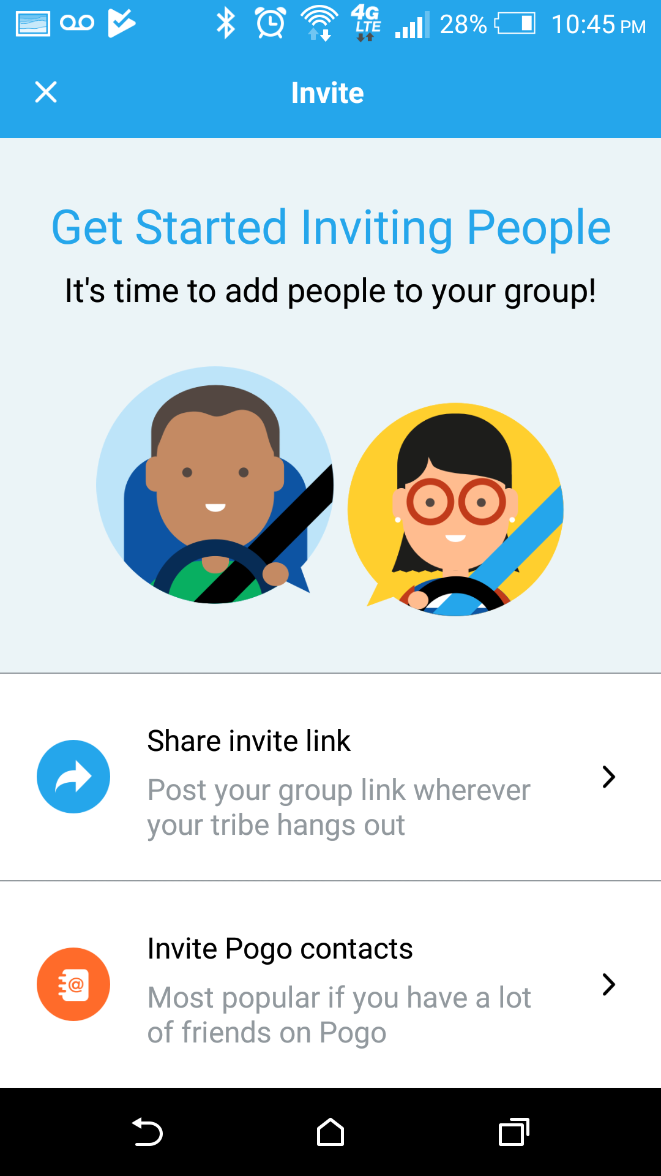
- Invite RideWhiz contacts
Vasant & Dhaiyur Comment: Can you please explain this functionality in detail.
Please ignore this for now. Just keep 'Share Invite link”.

- Share group invite link. Implement all the options below.
Vasant & Dhaiyur Comment: Okay

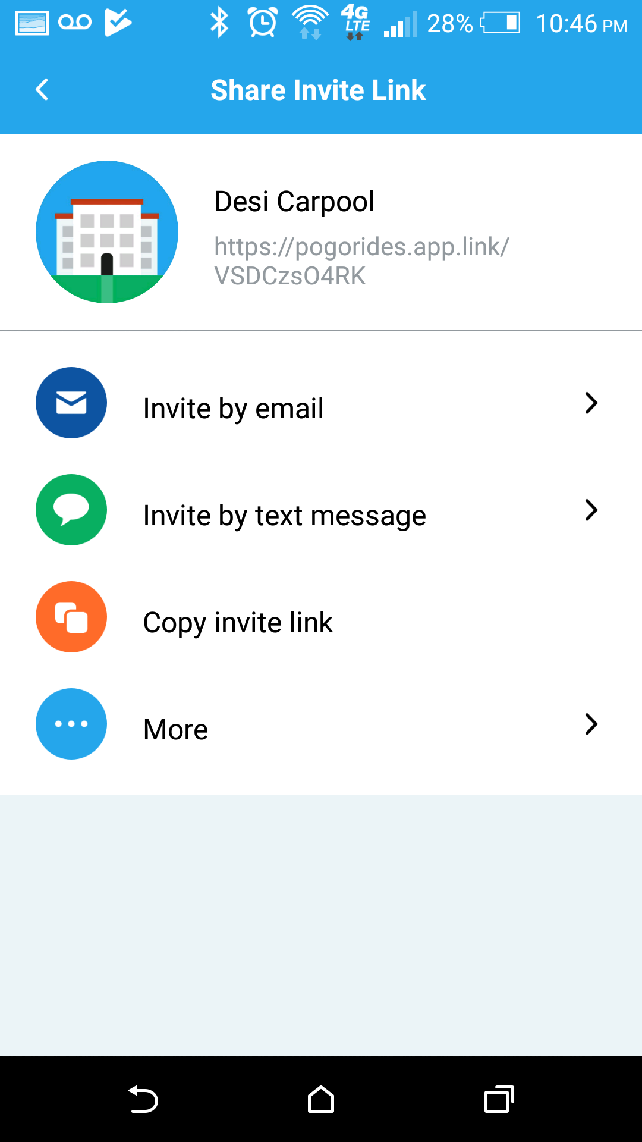

- Following changes when setting up a user.
- Present a series of screens to collect information about the user. Only one type of information should be on each screen. See the screens below. Use the default look and feel that we already have within RideWhiz.
Vasant & Dhaiyur Comment: In PoGo Ride app there are 7-8 screens and here you just showed 3 screens, so please confirm how many screens we have to implement.

You are right. But we have included only those screens which are applicable to RideWhiz. If you think think we missed any relevant screen, please let us know.
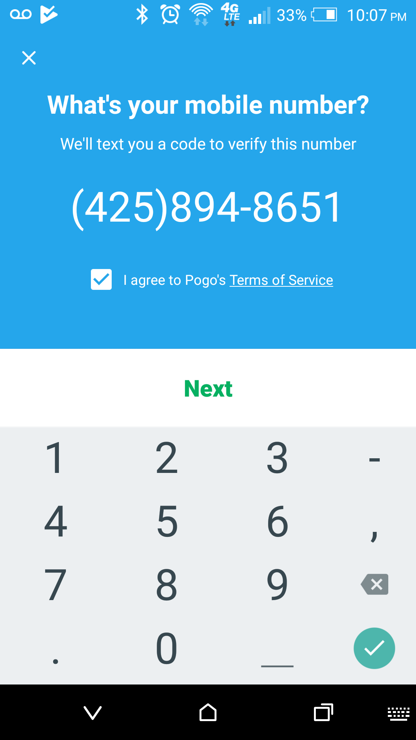

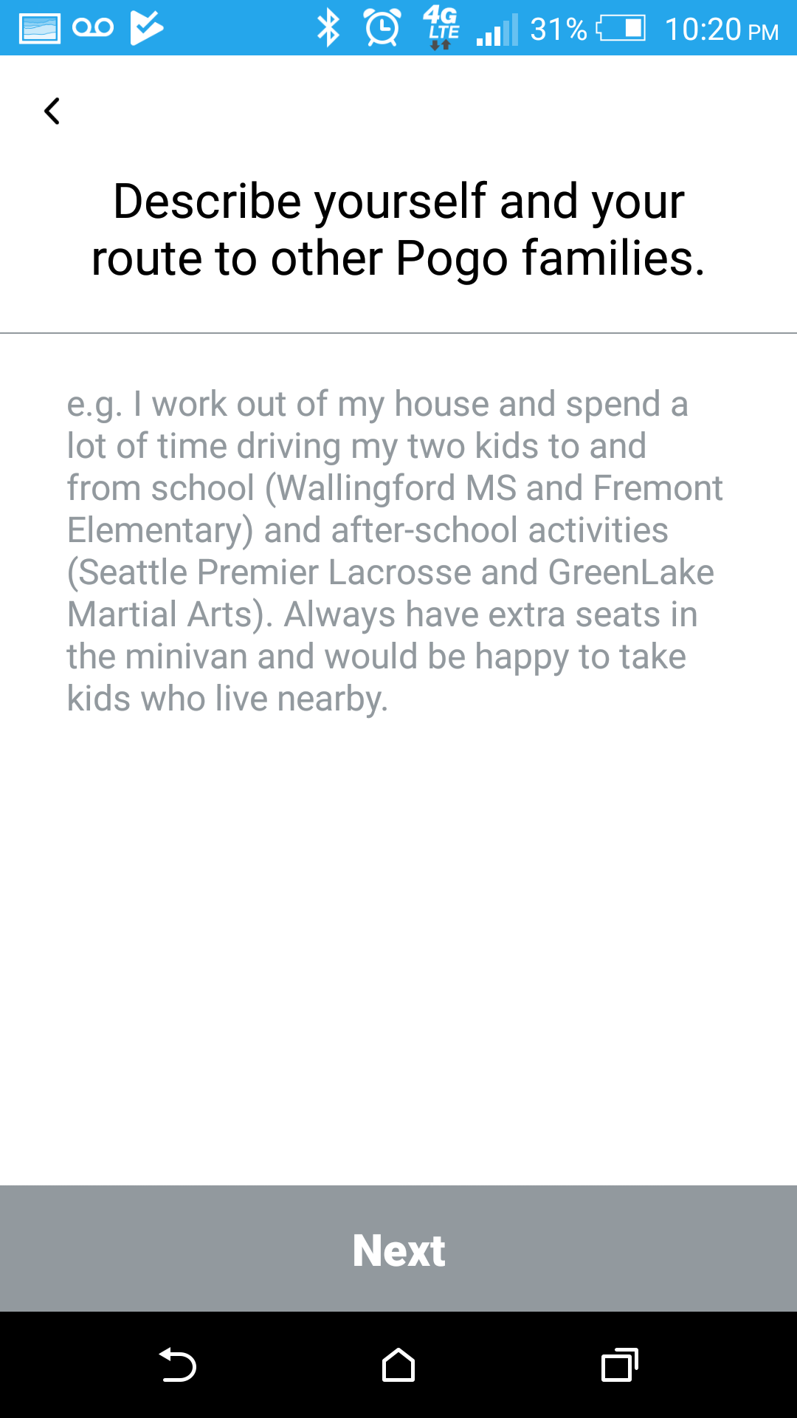

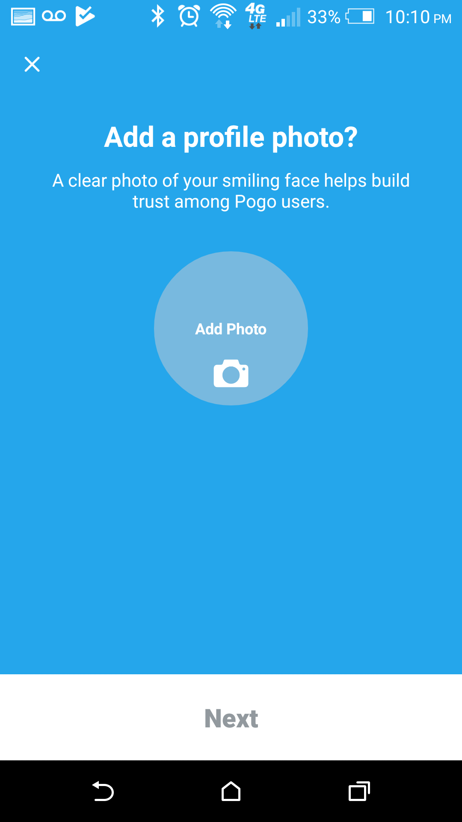

Other questions:
In PoGo Ride app following are the features.
Is we have to implement following features into RideWhiz App?

- Create Root: there are 7-8 screen for create root so do we have to make this feature in RideWhize app?
We don't want to create any routes in RideWhizApp. We handle that differently in RideWhiz.
- You want Discover screen?
Yes that's where a user can search for other groups and send a request to join.
- There will be any Group admin kind of functionality? Because we cant check this in PoGo Ride app.
- Don't know what they do in PogoRide. But for RideWhiz we will have one admin for each group and that will be the user who creates the group.
- Is anyone can edit the group who has joined the group? Or only user can edit who has created the group?
- Only admin can edit a group
- In group edit there is Enable Invite Code feature. Do we have to implement that?
- We haven't looked into that feature. Can you guys find out How that works.
- In Messaging(Chat) how many features you want like: only text chat when user online, image/video share, location share, etc, please describe how you want the Messaging feature?
- Let''s go with text chat for now. We can look into adding others later.

